**Homework 12**

**Type in your score here 🡪 ____ out of 23 points possible**

1. (5 points) Ponder/Reflect Exercise – Reflect on what you have learned from this portion of the class. Examples of what you can do are: a brief outline of material covered, insights you gained from class or personal study, or items you feel that you need to follow up or work on. (3-5 sentences)

**Any thoughtful answer is sufficient.**

2. A paper report on a study sponsored by CIFOR (Center for International Forestry Research) to evaluate the effectiveness of monitoring methods related to water and soil management. Part of the study considered soil runoff data from two catchment areas (area number 37 and 92) using runoff plots classified as “undisturbed/control” and “harvested” The runoff volume was calculated at each rainfall event, with the amount of rainfall serving as an additional factor at three levels (3.5-10 mm, 10-20 mm, and >20 mm). The data, consisting of four measurements per factor-level combination is in Soilrunoff.csv. Use Excel and R to complete the following parts using α=0.05.

Do the following.

1. Do a data decomposition and degrees of freedom of this analysis (6 points)



df = 1 df=1 df=2 df=1



Df=2 df=1 df=2 df=2 df=36

1. Complete an ANOVA table showing the sum of squares, degrees of freedom, F, and P-value for each of the main effects and all interactions using R. Also, check the requirement that the residuals are normal. Make Conclusions based off of the results (3 points)

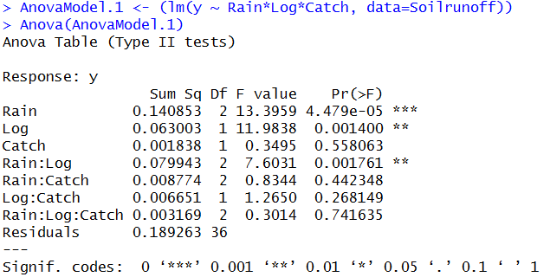

**The effects of Rain, Log, Rain*Log are significant.**

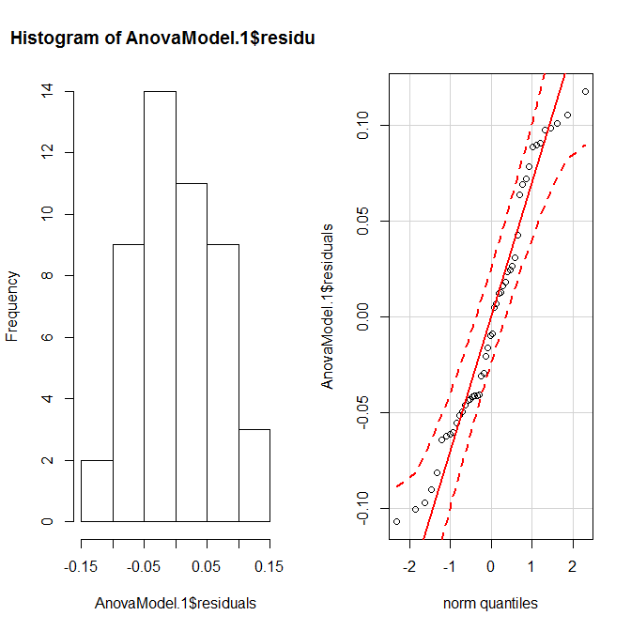

**The residuals seem relatively normal.**

3. A machine is used to fill 5-gallon metal containers with soft drink syrup. The variable of interest is the amount of syrup loss due to frothing. Three factors are thought to influence frothing: the nozzle design, the filling speed, and the operating pressure. Three nozzles, three filling speeds, and three pressures are chosen with two replicates.

Using the soft drink syrup data, do the following.

1. Do a data decomposition and degrees of freedom of this analysis (6 points)





(b) Complete an ANOVA table showing the sum of squares, degrees of freedom, F, and P-value for each of the main effects and all interactions using R. Also, check the requirement that the residuals are normal. Make Conclusions based off of the results (3 points)

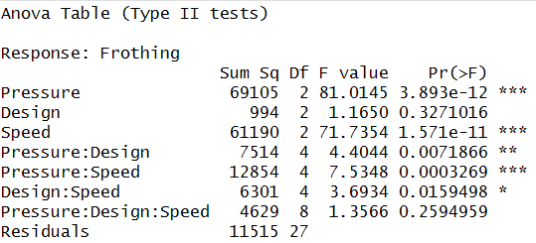

**Pressure, Speed, and all Two-Way interactions are significant. The interactions should be in the main spot in this analysis.**



**There is a some concern about outliers, but we may be able to assume that the residuals are normal.**